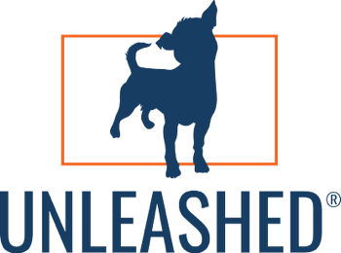
Unleashed® Leadership Circle: Insights That Shaped the Vision
A Market Research Summary from Interviews with Business & Nonprofit Leaders
Overview
In May and June 2025, I conducted in-depth interviews with leaders across industries—CEOs, nonprofit directors, and founders—to understand their greatest leadership challenges, aspirations, and gaps in current support systems.
Their insights helped shape the Unleashed® Leadership Circle—a bold new space for leadership, life integration, and strategic clarity.

Key Themes & Takeaways

Leadership Feels More Complex Than Ever
- Volatility in business, government, laws, and society is accelerating.
- Leaders struggle to stay current, grounded, and strategic in the chaos.
“The speed of change—and trying to understand broader issues—has been overwhelming.”
- Charlie, Nonprofit Executive Director

High-Trust Peer Groups Are Lacking
- Most leaders feel isolated. They want smart, experienced peers who challenge and support them—without judgment.
- There's a need for intimate, strategic peer settings—not “networking groups.”
“I want something that stretches me—where people bring real experience, not just titles.”
- Gary, CEO

Mental Load and Decision Fatigue Are Real
- Decision fatigue, emotional weight, and too much “doing” surfaced in every interview.
- Leaders crave time to think, pause, and gain clarity on what really matters.
“Sometimes I’m so deep in the operations, I don’t have space to think about what matters most.”
- Sean, Business Owner

AI Curiosity is High—but Strategic Use is Low
- Most are dabbling in AI tools (like ChatGPT), but don’t know how to use them as strategic leadership enhancers.
“I’d like to use AI more intentionally to help me lead smarter—not just save time.”
- Charlie
“We’re starting to explore AI for marketing and customer service, but I know we’re barely scratching the surface of what’s possible.”
- Gary

Growth Requires Integration—Not Just Execution
- Leaders want development that supports their full life—not just their business.
- They’re tired of separating life from leadership; they want programs that support both.
“If we’re not growing as people, we’re not growing as leaders.”
- Diana, CEO
“I’m not looking for another assignment, I’m looking for something that helps me grow without adding more to the plate.”
- Justin, Business owner

They Value Real Talk Over Frameworks
- Most traditional leadership development programs are seen as too academic, too formal, or too fluffy.
- There’s a hunger for candor, clarity, and conversations that matter.
“I don’t want more structure; I want people who will challenge me when I need it.”
- Ken, CEO

The Solution: Unleashed® Leadership Circle
A high-trust, small-group leadership experience designed to:
- Make space for strategic thinking
- Integrate AI as a practical leadership tool
- Sharpen communication, confidence, and decision-making
- Create meaningful personal growth
- Provide a real, respected circle of advisors and peers

About Dan Weedin
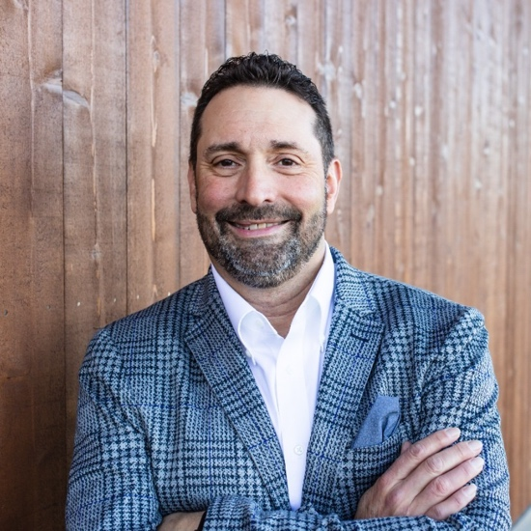
Dan Weedin is a leadership strategist, business advisor, and speaker who’s been coaching entrepreneurs, executives, and nonprofit leaders for over 20 years. He’s built companies, served on school boards, coached high school sports, and helped clients navigate everything from sudden crises to major growth.
Dan’s known for his direct style, sharp wit, and ability to turn complexity into clarity. He created the Unleashed® Leadership Circle to give leaders a space to think bigger, lead better, and build lives they don’t need a vacation from.
When he’s not consulting, coaching or speaking, you’ll probably find him on the golf course or chasing after his dog, Bandon, in Poulsbo, WA

